For Newsletter, 19th October 2025
(29th Sunday in Ordinary Time – also World Mission Sunday)

Missionaries of Hope Among all Peoples
Well before Pope Francis took ill and died, He wrote a letter for World Mission Sunday entitled “Missionaries of Hope Among all Peoples” (Available on www.missio.nz). Besides highlighting that this day is a day of prayer and commitment to the universal mission of the Church, he also reminded “individual Christian and the entire Church, the community of the baptized, of the fundamental vocation to be, in the footsteps of Christ, messengers and builders of hope.”

Providence has it that Pope Francis’ successor, Pope Leo XIV, is a missionary priest. In 1987, the young Father Robert Prevost walked into a Peruvian village where the nearest priest was a three-day journey away. There, families lived and died without the sacraments. Children grew up without the Mass. The villagers had never seen a seminary. Today, that village has its own parish, its own priest, and has planted two more churches in neighbouring communities. The missionary who changed everything now leads the universal Church as Pope Leo XIV—the first pope from the United States. Pope Leo XIV's missionary work didn't end when he first left Peru in 1999. It multiplied. The seeds he planted with calloused hands are still growing into forests of faith. That's the power of true legacy.

We can all participate in the Pope’s missionary endeavours by our prayers and by financial contributions towards the Pontifical Mission Societies. Although for some, Mission Sunday would appear like a once-a-year event, in reality, many generous people support the Pontifical Mission Societies through their regular donations. Some set up bequests to ensure they can continue to sow the hope around the world even after their earthly pilgrimage has ended.

Imagine, if a young priest's 22 years in Peru could impact thousands of souls across decades, what could your regular support, or your bequest, accomplish for God's mission? An American lady who recently put the Pontifical Mission in her will said: “I never imagined I could afford estate planning. Now I have peace knowing my small savings will help plant churches somewhere in the world, just like Pope Leo XIV did in Peru".

Please support the Pontifical Mission Societies – and be missionaries of hope among all peoples.

Fr Michael Pui
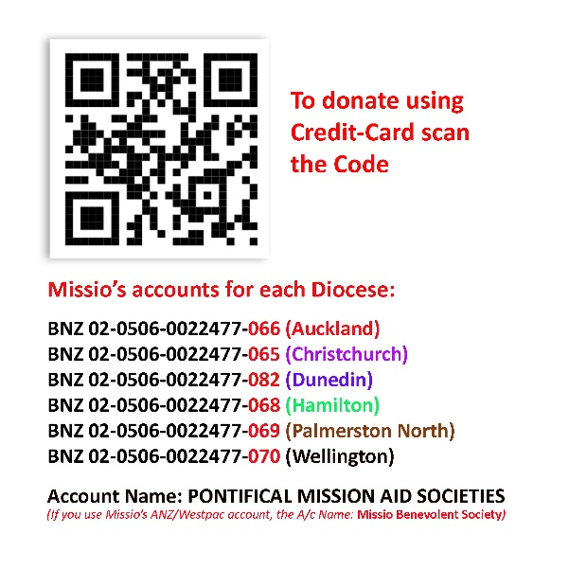
NZ National Director of the Pontifical Mission Societies

